**Project 1**

Wayne Yeung (1007174585)

Department of ICCIT, University of Toronto Mississauga

CCT260H5S: Web Development and Design I

Professor: Danny Papagiannis

July 22, 2024

**Section 1: Content Study & IA**

**Fig 1a (Original Unmodified Version)**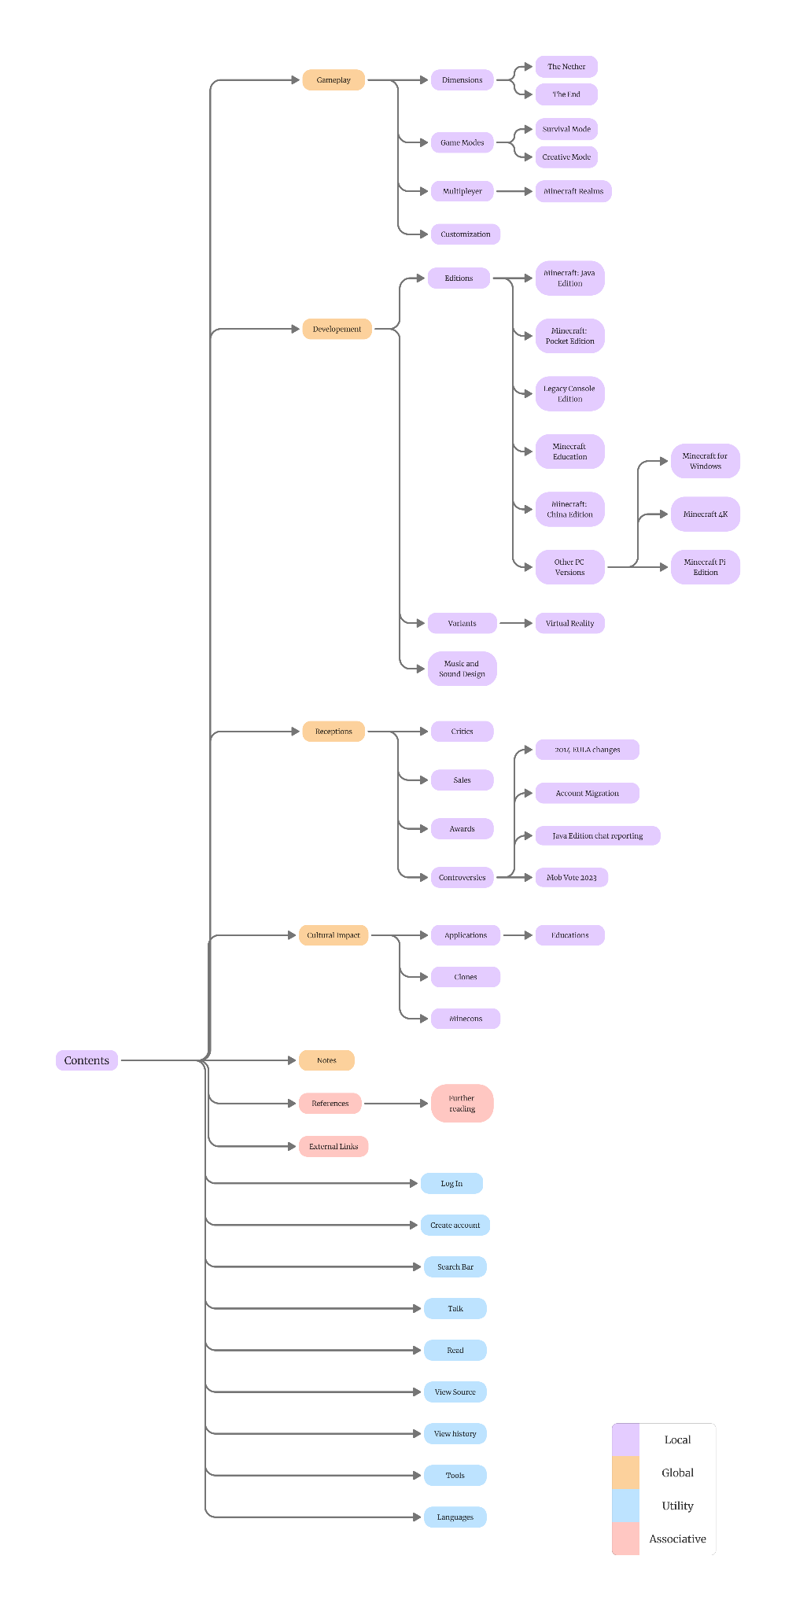

**Fig 1b (Revised Desktop Version)**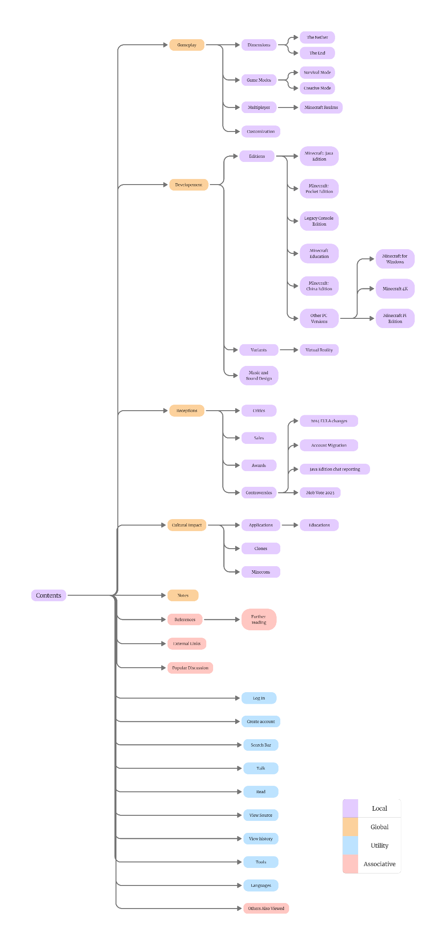

**Fig 1c (Revised Mobile Version)**

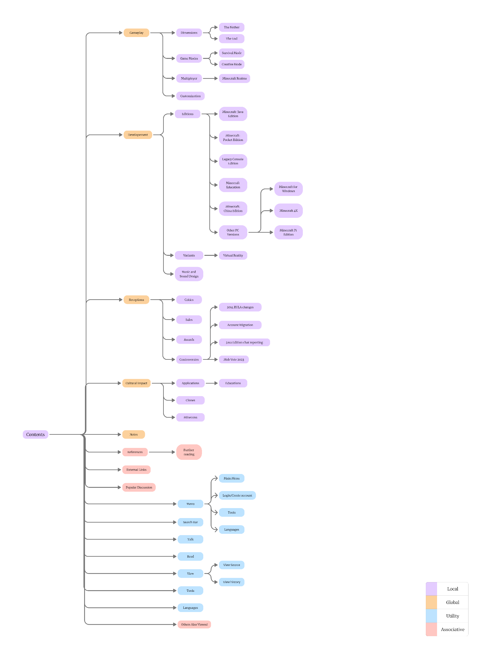

#### **Tailoring IA for Desktop and Mobile**

First, I specifically tailored two separate Information Architectures (IA) for desktop and mobile versions to suit their respective displays. Here are the reasons for this approach:

1. **Screen Size and Resolution**
   1. Desktop screens generally have larger displays and higher resolutions compared to mobile devices. This allows for more content to be displayed simultaneously without overwhelming the user. Therefore, the desktop IA can include more visible subcategories and detailed navigation options.
   2. Mobile screens are smaller and require more simplified navigation to ensure readability and ease of use. By tailoring the IA specifically for mobile, I ensured that users can easily navigate through content with simplified menus.
2. **User Interaction Patterns**
   1. Desktop users often navigate using a mouse and keyboard, which allows for precise clicks and hover effects. This interaction pattern supports more complex navigation structures and dropdown menus.
   2. Mobile users navigate primarily through touch gestures, which necessitates larger clickable areas and more straightforward navigation paths. Tailoring the IA for mobile ensures that users can interact with the site comfortably and efficiently, avoiding frustration from mis-taps or difficult navigation.
3. **Content Prioritization**
   1. On desktop, it is possible to display more information at once, allowing for a richer content experience. The desktop IA includes more detailed secondary and tertiary navigation to cater to users who seek in-depth information.
   2. On mobile, content needs to be prioritized to avoid overwhelming the user. Essential content and primary navigation options are displayed more prominently, with less critical information being accessible through expandable sections or secondary menus.

**Changes to Desktop IA**

For the desktop IA, I only made minimal changes by adding the "Others Also Viewed" and "Popular Discussions" sections. Here are the reasons for these additions:

1. **Enhanced User Engagement (Others Also Viewed)**
   1. The "Others Also Viewed" section helps users discover related topics and content that other users found interesting. This addition is based on the design principle of associative navigation, which connects related content to improve user engagement and retention.
   2. Users might be looking for specific topics related to Minecraft, and this section assists them in finding relevant information effortlessly. It also encourages users to explore more of the site.
2. **Community Interaction (Popular Discussions)**
   1. The "Popular Discussions" section provides users with access to current conversations and debates within the Minecraft community. This addition leverages social proof, where users are influenced by what others are engaging with.
   2. Including popular discussions helps users stay informed about trending topics and common concerns within the community. This not only enhances the sense of community but also provides valuable insights into what other users are interested in or concerned about.
3. **Consistency and Usability**
   1. Maintaining the overall structure of the desktop IA ensures consistency, which is crucial for user familiarity and ease of use. By only adding these two sections, the core navigation and structure remain intuitive and familiar to returning users.

**Changes to Mobile IA**

For the mobile version of the Minecraft Wikipedia page, I implemented significant changes to the navigation by incorporating the main menu, login/create account, tools, contents, and languages into a hamburger menu. Here are the reasons for these changes:

1. **Screen Optimization**
   1. Mobile devices have significantly smaller screens compared to desktops. By consolidating various navigation options into a hamburger menu, I maximized the available screen space for displaying content. This ensures that users can view more information without being overwhelmed by navigation elements.
   2. The hamburger menu keeps the interface clean and uncluttered, which is crucial for mobile usability. Users can focus on the content without distractions from numerous navigation links.
2. **Ease of Navigation**
   1. The hamburger menu serves as a centralized hub for all navigation options, providing users with a single point of access to all essential functions and sections.
   2. Users are familiar with the hamburger menu icon, making it an intuitive choice for accessing navigation on mobile devices. This familiarity enhances usability and reduces the learning curve.

**Section 2: Wireframes**

**Fig 2a (Desktop Home Page)**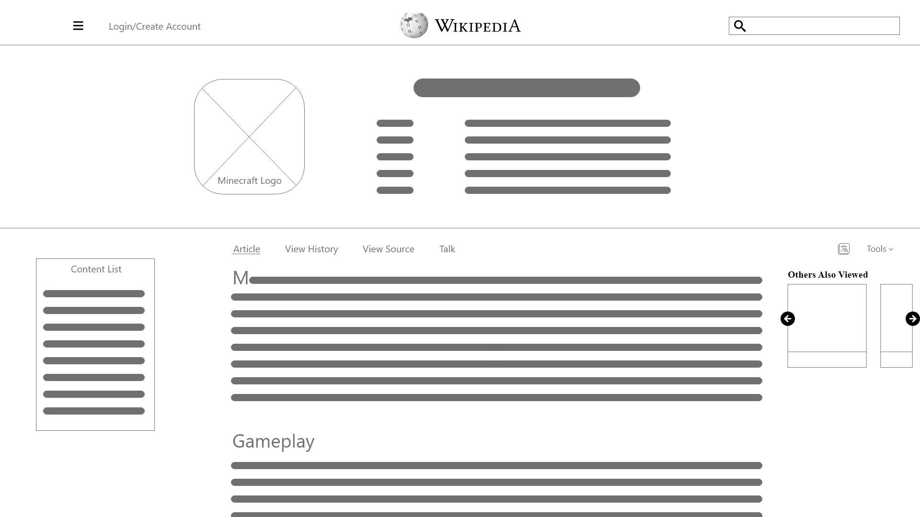

**Fig 2b (Desktop Inner Content Page)**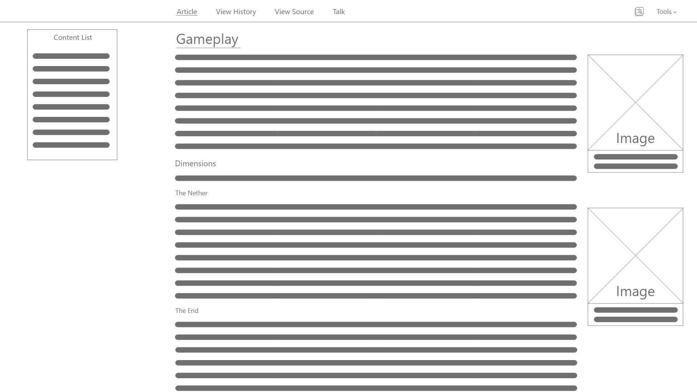

**Fig 2c (Desktop Popular Discussion Page)**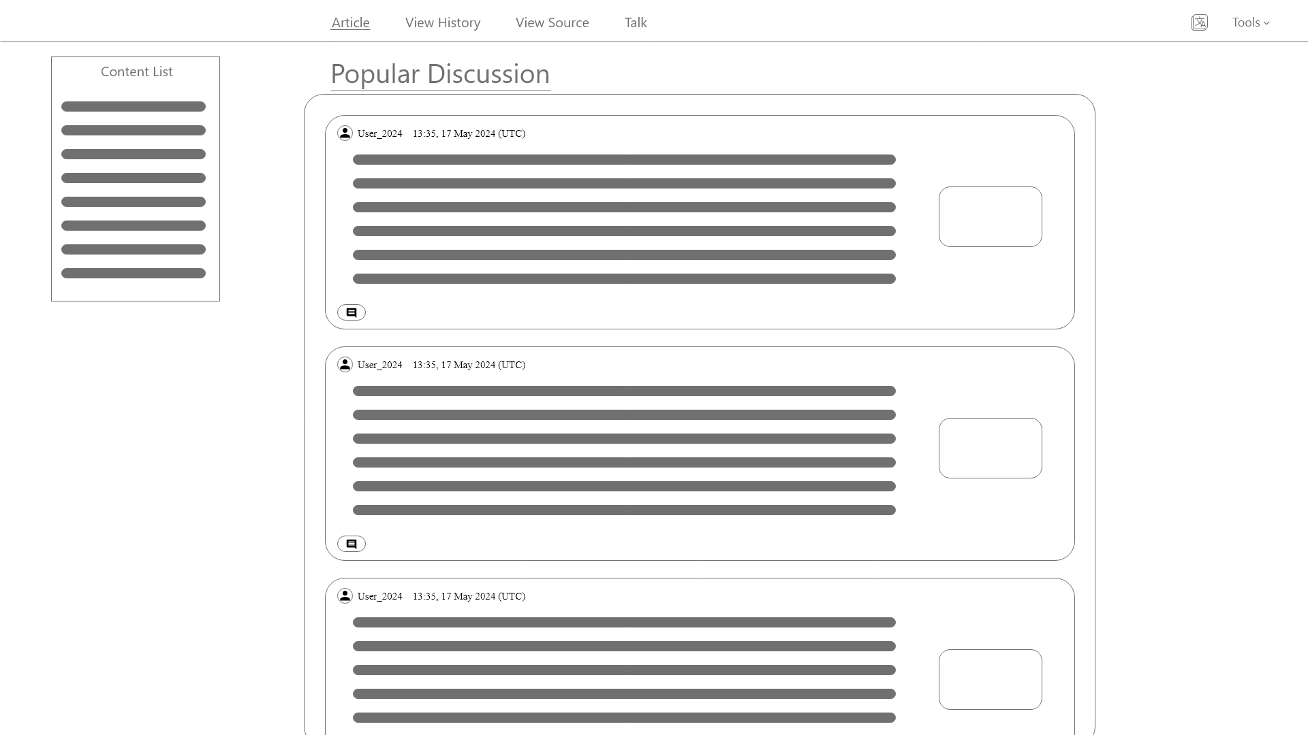

**Design Principle and Rationale (Desktop)**

1. **Consistency and Familiarity**
   1. Maintaining a consistent header and navigation structure across all pages ensures a seamless user experience. Users can easily navigate different sections without confusion.
2. **Cognitive Load Reduction**
   1. Simplified navigation and organized content help reduce cognitive load, making it easier for users to find and process information.
   2. Collapsible sections on mobile save space and prevent information overload.
3. **User Engagement**
   1. The inclusion of sections like "Others Also Viewed" and "Popular Discussions" encourages users to explore related content, increasing engagement and time spent on the site.
4. **Visual Hierarchy**
   1. Clear visual hierarchy is maintained through the use of headings, subheadings, and images. This guides users' attention to the most important content first, enhancing their overall experience

**Fig 2d (Mobile Home Page) Fig 2e (Mobile Inner Content Page)**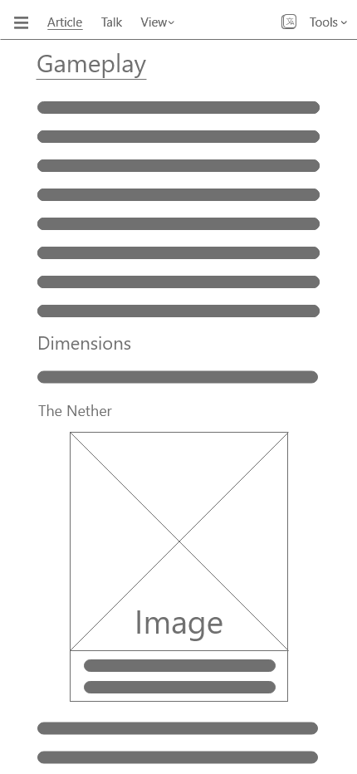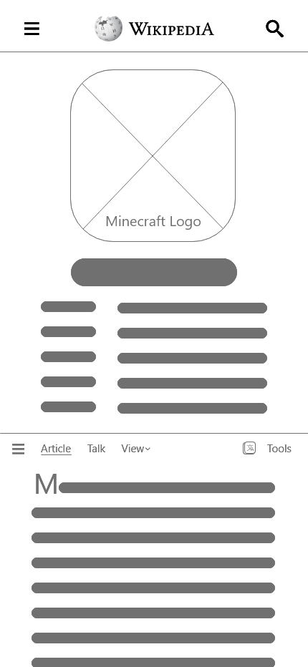

**Fig 2f (Mobile Popular Discussion Page) Fig 2g (Mobile Content List)**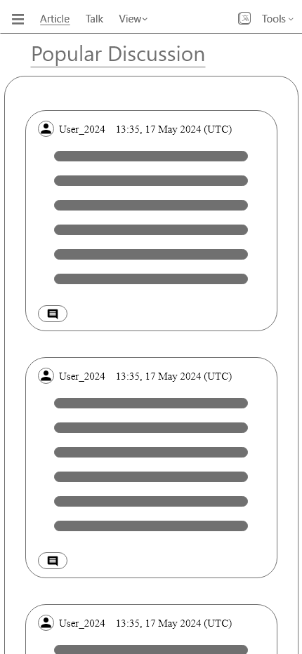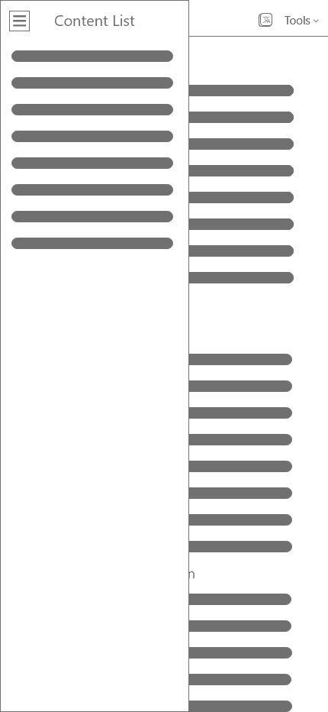

**Design Principles and Rationale (Mobile)**

1. **Screen Space Optimization**
   1. Given the limited space on mobile devices, consolidating navigation options into a hamburger menu frees up more room for the actual content. This ensures users can focus on reading and interacting with the main information without being distracted by cluttered navigation elements.
2. **Enhanced User Interaction**
   1. The streamlined interface ensures that users can navigate through different sections smoothly. The intuitive design of the hamburger menu, combined with touch-friendly elements, enhances the ease of interaction, making the website more user-friendly on mobile devices.

**Overall Design Principle and Rationale**

1. **Immediate Access to Key Information**
   1. Placing the Minecraft info card at the top of the page ensures that critical details about the game, such as developers, publishers, designers, release date, and platforms, are immediately accessible to users. This eliminates the need for users to scroll down to find basic information, providing a more efficient and user-friendly experience.
2. **Monochromatic Color Scheme**
   1. **White, Black, and Grey Palette:** Given the text-heavy nature of a Wikipedia page, the use of a monochromatic color scheme helps maintain readability and reduces visual fatigue. The neutral tones ensure that the focus remains on the content without any color distractions.
   2. **Enhanced Contrast:** The high contrast between the background (white) and text (black) ensures that long paragraphs of text are easy to read, which is critical for a page filled with detailed information. This design choice aligns with the Web Content Accessibility Guidelines (WCAG).
3. **Minimalist Design**
   1. **Whitespace Utilization:** The strategic use of whitespace around paragraphs, headings, and images prevents the page from appearing overwhelming, making it easier for users to process and digest the information.
4. **Typography**
   1. **Typographic Hierarchy:** Effective use of different font sizes and weights to distinguish headings, subheadings, and body text helps users navigate through the page. This hierarchy allows users to scan the page quickly and find the sections they are interested in.
5. **Sticky Section Headers**
   1. **Improved Context Awareness:** By keeping the section title visible, users can easily understand where they are within the article. This is especially useful for long pages with extensive content on Wikipedia page, as it prevents users from feeling lost and improves overall content comprehension.

**Section 3: Rich Media Production**

**Fig 3a Minecraft Logo**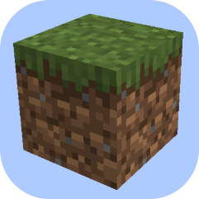

It is a cropped screenshot from Minecraft showing a dirt block which is a very common and essential block in Minecraft, which makes it very iconic, hence choosing it as the logo

**Fig 3b Minecraft Panda**

It is a cropped screenshot from Minecraft showing a panda, which is topic for the Other Also Viewed section.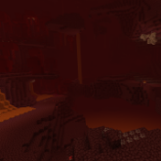

**Fig 3c Minecraft Nether**

It is a cropped screenshot from Minecraft showing the Nether, which is another topic for the Other Also Viewed section.

**Fig 3c Minecraft The End**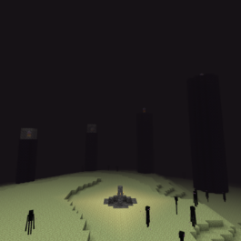

It is a cropped screenshot from Minecraft showing the End dimensions, which is a subsection under Gameplay dimension section.

**Fig 3d Gameplay Action**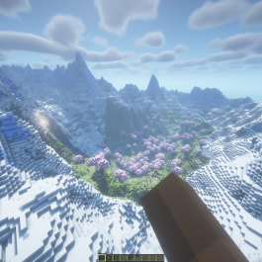

This screenshot captures a moment of gameplay action, which is an image showcase for the Gameplay Section.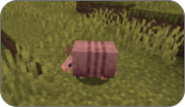

**Fig 3e Gameplay Action**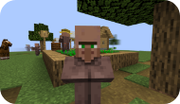

This screenshot captures a Minecraft Armadillo, which is related to the mob vote in the discussion section.

**Fig 3f Village and Villagers**

This screenshot captures a village with lots of villagers, which is related to the “Villages and Villagers” in the discussion section.

**Section 4: Finalised Prototype**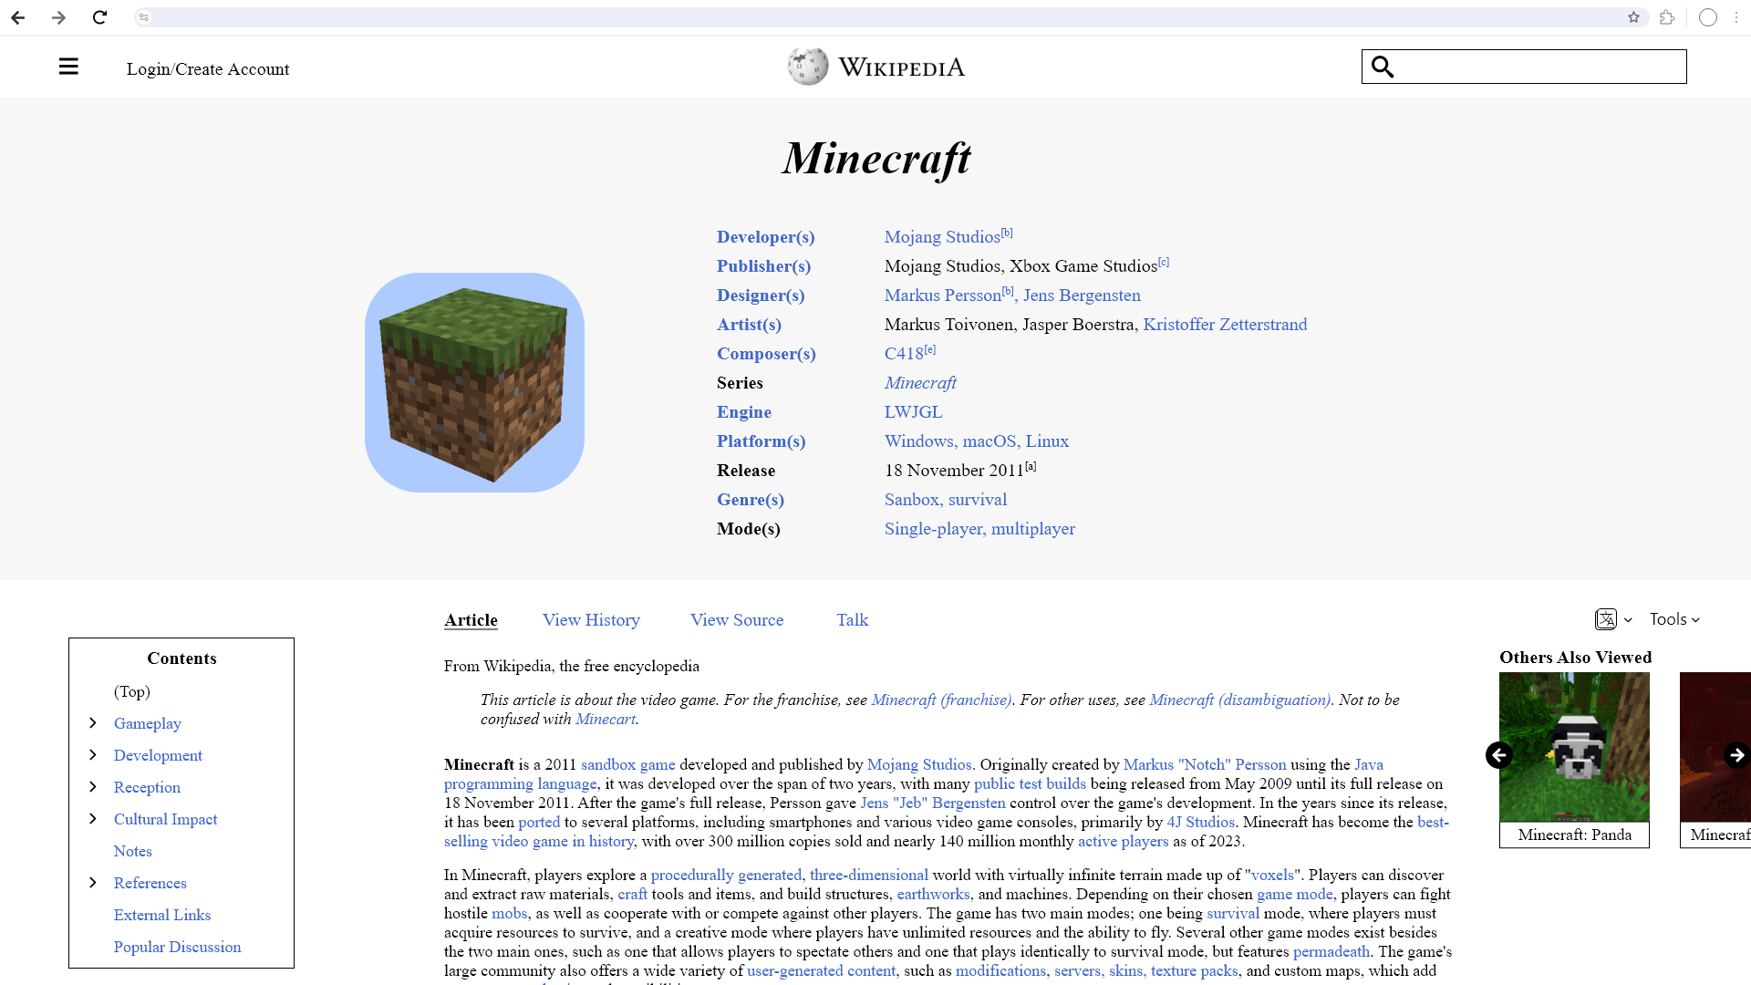

**Fig 4a Desktop Home Page**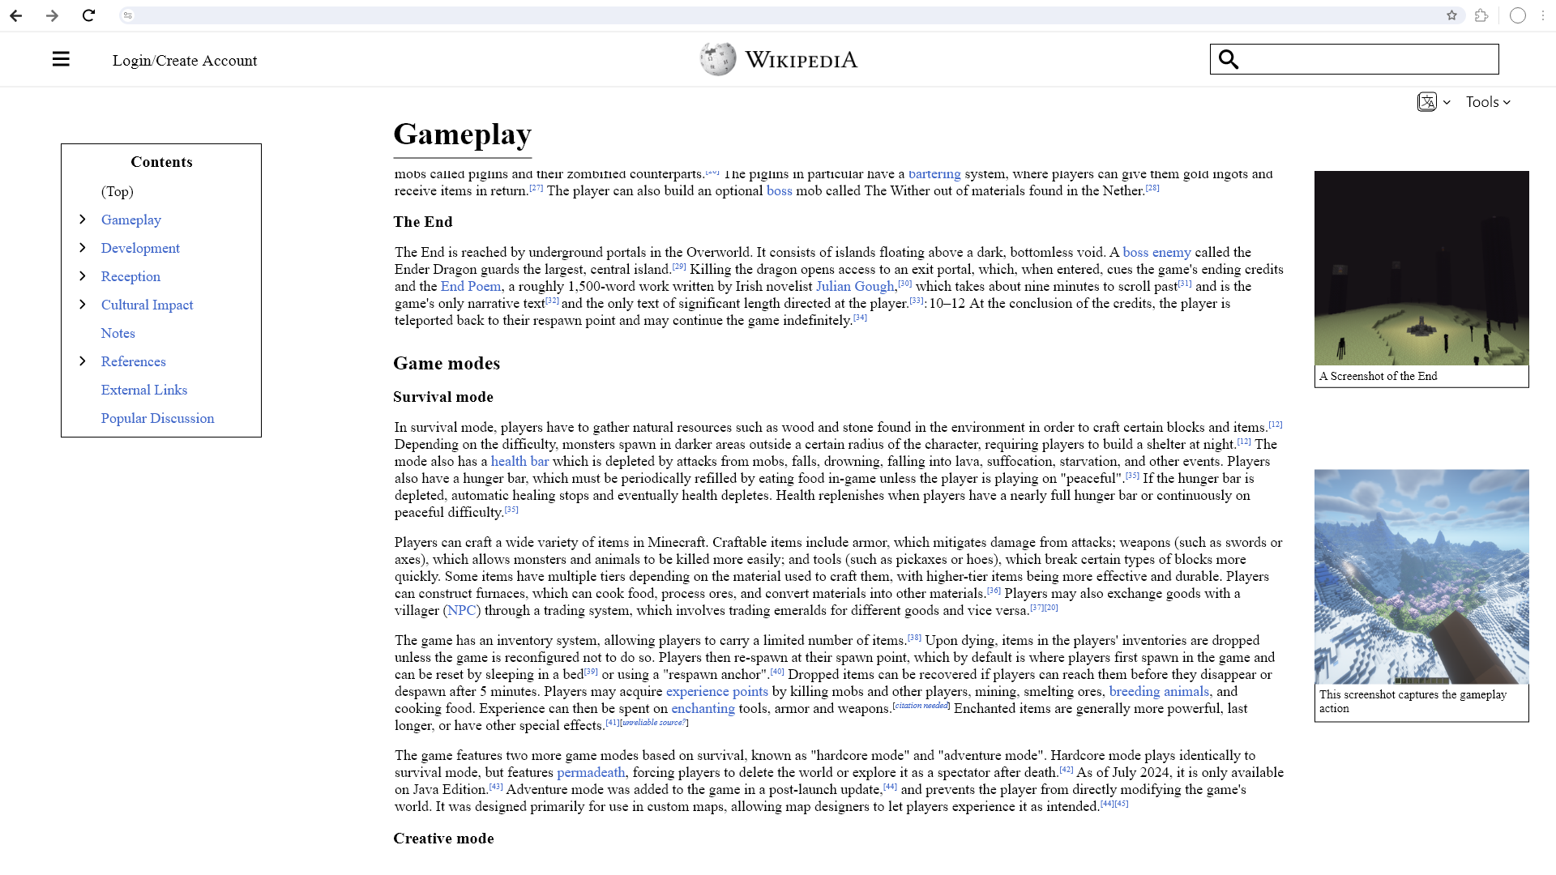

**Fig 4b Desktop Inner Content Page**

**Fig 4c Desktop Popular Discussion Page**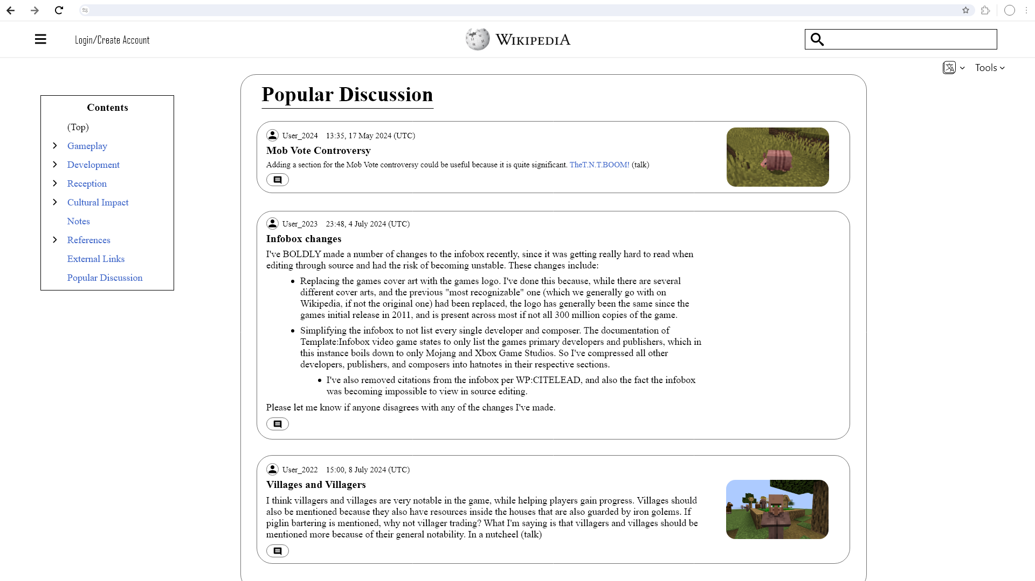

**Fig 4d Mobile Home Page Fig 4e Mobile Inner Content Page**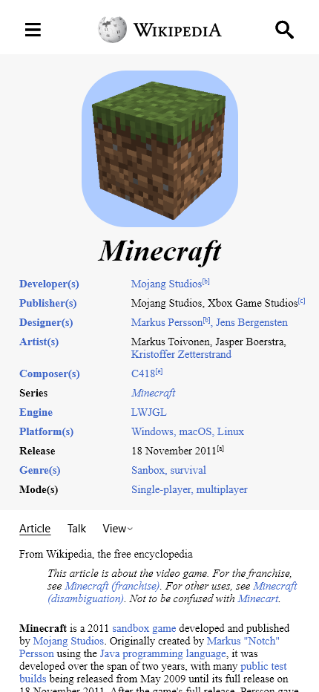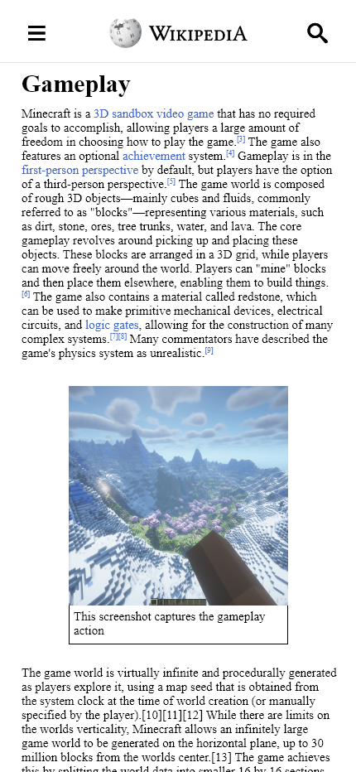

**Fig 4d Mobile Discussion Page Fig 4d Mobile Hamburger Menu**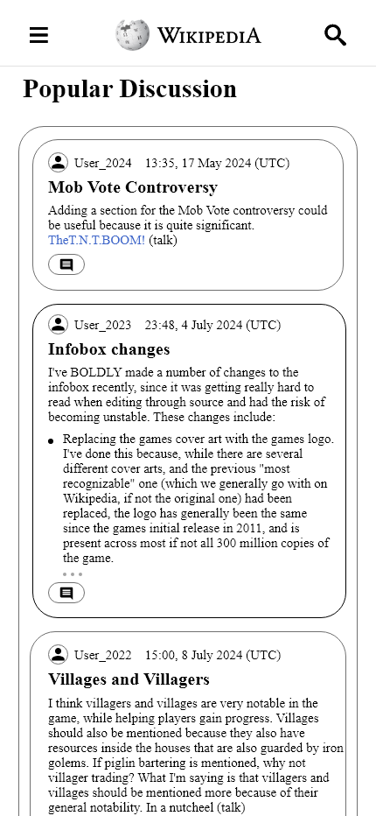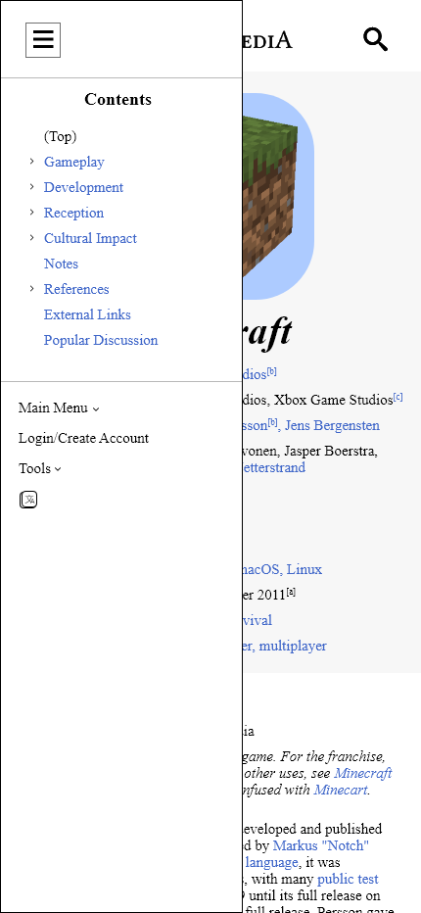

**Section 5: Process**

**Changes in the Design of the mobile layout**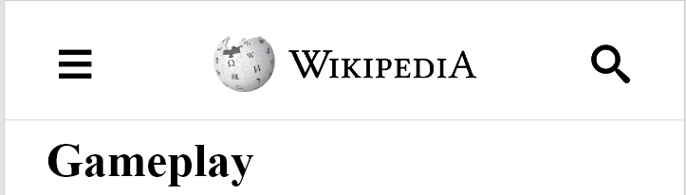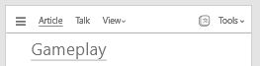

**Fig 5a Original Design Fig 5b Final Design**

In the finalized version of the mobile design, the top navigation that remains fixed while scrolling has been simplified. The first image (finalized version) shows a navigation bar that includes the Wikipedia logo, a hamburger menu, and a search icon. The second image (wireframe version) included additional elements such as links to "Article," "Talk," "View," and "Tools." The reasons are

1. **User Behavior Consideration:** During the middle of reading, users are less likely to need access to options such as "Talk" or "View." These functions are more relevant when users initially navigate the page or after they have finished reading. Keeping only the essential navigation elements (hamburger menu and search) accessible ensures that users can still perform necessary actions without being overwhelmed.
2. **Cleaner Interface:** The simplified top navigation contributes to a cleaner and more aesthetically pleasing interface. It reduces visual clutter and enhances the overall look of the page.

**Fig 5c Original Hamburger Menu Fig 5d Finalised Hamburger Menu**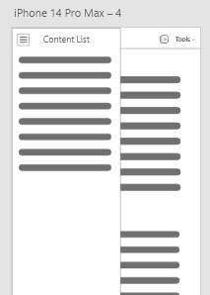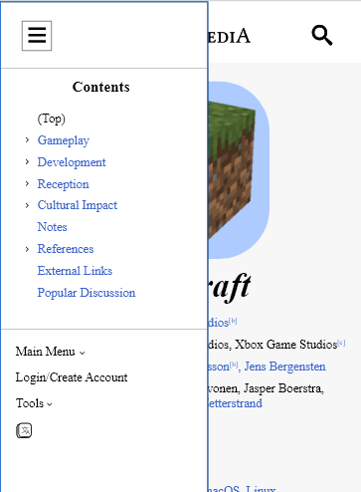

The finalized Hamburger Menu now includes the main menu and login/create account buttons, which were missing in the original wireframe design. Additionally, the Tools and Language buttons have been incorporated as well.

**Fig 5e Original Sticky Header Fig 5f Finalised Header**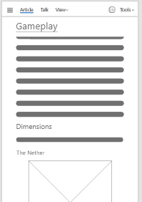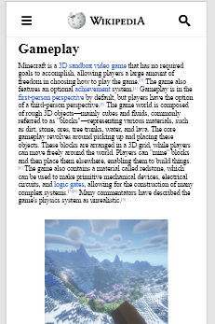

In the finalized design, the sticky header that was present in the wireframe version has been removed. While having a sticky header is beneficial for helping readers know which section they are in, the decision to remove it was based on several important considerations.

1. **Maximized Content Area:** Mobile screens have limited space and every pixel counts. Removing the sticky header maximizes the available screen space for content, ensuring that more of the article is visible without the need to scroll as frequently.
2. **Reduced Header Overlap:** Sticky headers can sometimes overlap with important content, especially when users zoom in or out, which is very common for mobile users. Removing the sticky header ensures that there is no interference with the content, providing a cleaner and more user-friendly interface.

**Changes in the Design of the desktop layout**

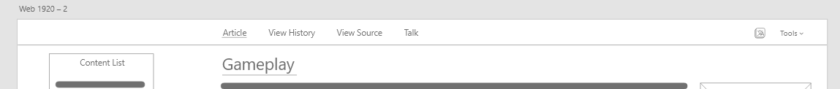

**Fig 5g Original Top Navigation**



**Fig 5h Finalized Top Navigation**

In the finalized design, the sticky header that was present in the wireframe version has been removed just like in the mobile version, but the language and tools buttons will be kept. It is changed because of user behavior considerations as mentioned in the mobile version, during extended reading sessions, users would rarely use the view history, view source, and talk buttons, leaving it no reason to stick to the top while scrolling.

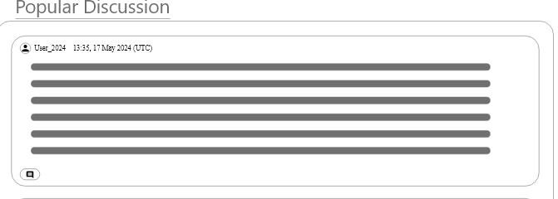

**Fig 5i Original Discussion Bubble**

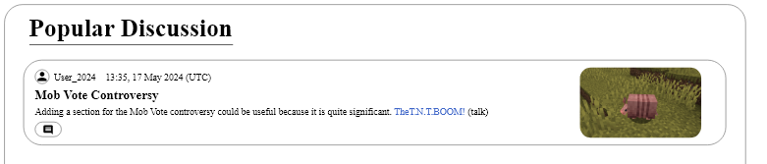

**Fig 5j Finalized Discussion Bubble**

In the transition from the wireframe to the finalized version of the Popular Discussion section, specific enhancements were made to incorporate images and improve the overall visual presentation of discussions.

1. **More informative:** Images help users quickly grasp the topic of the discussion and add a visual break to the text-heavy content.
2. **Visual Appeal:** A visually appealing design attracts users and encourages them to engage with the content. The use of images makes the discussion section more attractive and user-friendly.

**Section 6: Conclusion**

In summary, the redesign of the Minecraft Wikipedia page involved several thoughtful changes to both the desktop and mobile layouts, aimed at enhancing user experience, readability, and engagement.

**Desktop Version**

The desktop version retained most of its original structure but included strategic additions such as the "Others Also Viewed" and "Popular Discussions" sections. These additions serve to:

1. **Enhance User Engagement:**
   1. By providing related content that users might find interesting, the "Others Also Viewed" section encourages further exploration and interaction with the site.
2. **Foster Community Interaction:**
   1. The "Popular Discussions" section allows users to stay updated on current conversations and debates within the Minecraft community, enhancing the social aspect of the page.
3. **Maintain Consistency:**
   1. Minimal changes ensure that the familiar navigation structure is preserved, promoting ease of use and user familiarity.

**Mobile Version**

Significant changes were implemented in the mobile version to accommodate the smaller screen size and touch-based navigation, including:

1. **Screen Optimization:**
   1. Consolidating navigation options into a hamburger menu maximizes screen space for content, providing a cleaner and less cluttered interface.
2. **Ease of Navigation:**
   1. The intuitive hamburger menu offers a centralized hub for all navigation options, ensuring users can easily access essential functions.
3. **Enhanced Reading Experience:**
   1. Removing the sticky header maximizes content visibility and minimizes distractions, allowing users to focus on reading without interruption.

**Overall Design Principles**

The redesign incorporated several key design principles to improve user experience:

1. **Immediate Access to Key Information:**
   1. Placing the Minecraft info card at the top ensures critical details are immediately accessible, improving efficiency and user satisfaction.
2. **Monochromatic Color Scheme:**
   1. Using a white, black, and grey palette maintains readability and reduces visual fatigue, aligning with WCAG guidelines for enhanced contrast.
3. **Minimalist Design:**
   1. Strategic use of whitespace and a clear typographic hierarchy prevent the page from feeling overwhelming and guide users' attention effectively.
4. **Sticky Section Headers:**
   1. Keeping section titles visible improves context awareness, helping users navigate long articles without feeling lost.
5. **Visual Appeal and Usability:**
   1. Incorporating images in the Popular Discussion section makes the content more engaging and visually appealing, encouraging user interaction.

The redesigned Minecraft Wikipedia page demonstrates a balanced approach to improving usability and visual appeal while maintaining consistency and familiarity for users. By tailoring the design to suit both desktop and mobile environments, the page offers an optimized experience across different devices, ensuring that users can access and interact with content seamlessly. These enhancements collectively contribute to a more engaging, informative, and user-friendly platform.